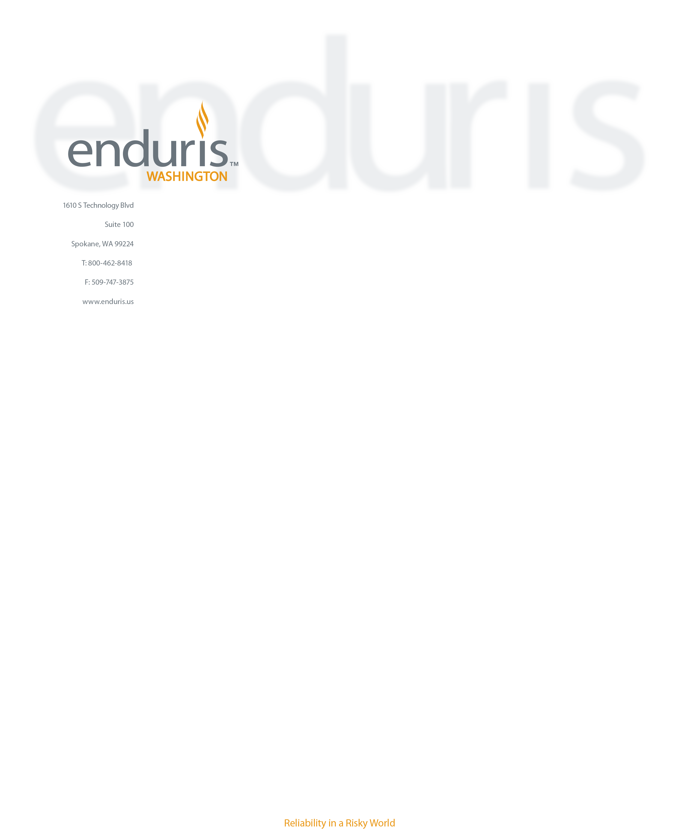July 29, 2021

Anne Presson

Orcas Island Health Care District

PO Box 226

Eastsound, WA 98245-0226

Dear Anne Presson,

Welcome to Policy Year 2022!

We are grateful for your continued membership and look forward to serving you this year. Your organization’s renewal documents are attached to this email and include a Policy Binder, Policy Schedules, Renewal Invoice and, if applicable, Vehicle ID Cards and Evidence of Coverage (EOCs).

Invoices are due on the date of renewal, September 1, 2021. Please note, past due amounts will incur interest until the balance is paid in full as Enduris has already paid the reinsurance costs for the Pool.

If you received renewal Evidence of Coverage (EOC) certificates, Enduris is also mailing a copy to the Certificate Holder for notification purposes.

Enduris continues to be impacted by the hard insurance market (now in its fourth year) as reinsurers attempt to re-calibrate rates to current market conditions. The liability insurance market is carefully underwriting exposures due to increasing litigation trends and extremely costly social inflation claim settlements.

The Pool’s property reinsurance cost has increased 42% for the upcoming Policy Year 2022 renewal (September 1, 2021). The liability reinsurance cost is projected to increase 15%. Even with reinsurance rates rising higher than last year, Enduris members - through the value of pooling - can expect some insulation from the market. Member rate increases will be approximately 10-15% for property and 5-10% for all other lines (liability, auto physical damage, crime, and named position coverage).

Individual member contributions may be impacted by loss experience (losses in the last 5 years) and are directly impacted by increases or decreases in exposures (changes to property values, vehicles, or worker hours/emergency runs). Page two of your invoice has a member contribution overview. We strive to bring you exceptional coverage for a competitive price while adding value to your organization.

We continue to offer proactive employment related pre-defense services, specialized claims management, focused risk management services and training directed at reducing risk and mitigating costs. Check our website at [www.enduris.us](http://www.enduris.us) for upcoming opportunities and to access your member portal site.

We are looking forward to serving you this coming year. Thank you for your membership and your contribution towards the success of your pool, Enduris.

Sincerely,

Sheryl Brandt

Executive Director